**Linux Directory Command**

**>> pwd :-** The command stands for **print working directory** which displays your location currently you are working on. It will give the whole path starting from the root ending to the directory.

sh-4.3$ pwd

/home/cg/root

**>> cd :-** The command stands for current directory i.e. The directory in which the user is currently working.

cd<dirname>

For example :- cd ashish

Using this command you can move all over your directories in your system. In addition to this , you can move to previous directory or previous to previous directory , or anywhere.

1 . **Change from current directory to a new directory**

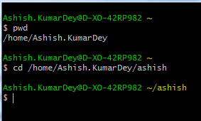

In the above screenshot , **pwd** command brings me to the current directory i.e. **/home/Ashish.KumarDey**.Then , cd command helps me to change from current directory to new directory i.e. **cd /home/Ashish.KumarDey/ashish**.Thus , the current directory changed to **ashish**.

2 . **Change directory using absolute path**

In absolute path , we have to mention whole path starting from root.

In addition to this , if you want to change the directory from ashish to swati , then you need to provide the whole path starting from the root i.e. / .

This is called absolute path.

**cd /home/Ashish.KumarDey/swati**

Please , see the below screenshot for your reference.

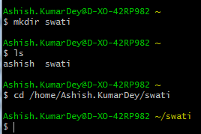

**3 . Change directory using the relative path**

In relative path , we don’t have to mention the whole path using root i.e. /.

In addition to this , we access the directory **ashish** from **Ashish.KumarDey** directory location.

**Please see the below screenshot for your reference**

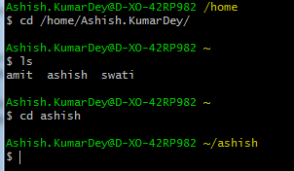

**4 . Brings you to the previous directory from the current directory**

cd<space> ..

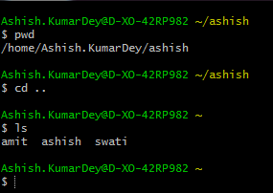

**Linux Path Completion**

**cd as --> ashish :-** If we want to type ‘**cd as**’ and hit tab then the command will be automatically completed i.e. **cd ashish**

**Note :- Path completion is extremely helpful in typing long file names where you don’t remember the full file name. However , in this case , you need to type the first letter correctly.**

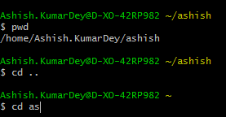

**>> ls :-** The command stands for list which shows list or content of your directory.

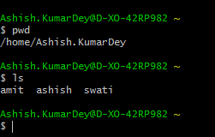

**>> ls -a :-** In Linux , hidden files starts with .(dot) symbol and they are not visible in the regular directory. The (ls - a) command will enlist the whole list of current directory including the hidden files.

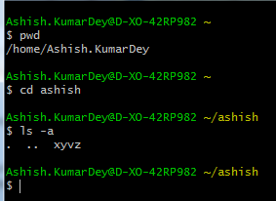

**>> ls -l :-** It will show the list in a long list format.

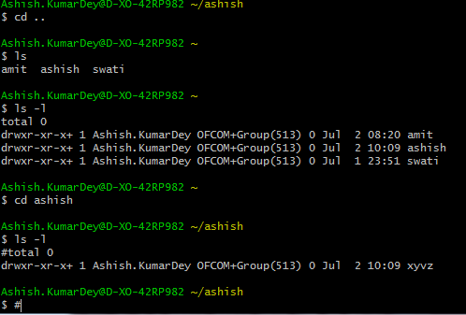

**>> ls -lh :-** This command will show you the file sizes in the human readable format. Size of the file is difficult to read when displayed in terms of byte. In addition to this , the command will give you data in terms of MB , GB , TB etc.

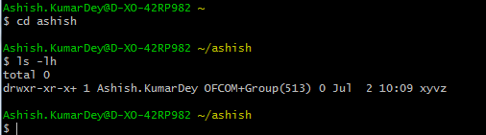

**>> ls -lhS :-** If you want to display files in terms of descending order(highest at the top) according to their size , then use this command.

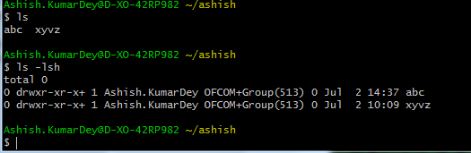

**>> ls -d */ :-** If you want to display only sub directories excluding all other files , then use this command.

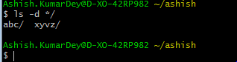

**>> ls -R :-** If you want to display the content of sub-directories also , then use this command.

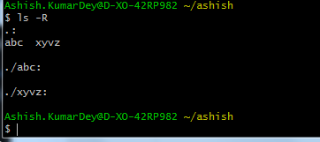

**>> ls -r:-** If you want to display list in the reverse order , then use this command.

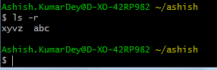

**>> ls -IX :-** It will group the files with same extensions together in the list.



**>> mkdir :-** This command stands for ‘**create directory**’ which helps you to create your own directory.

mkdir<dirname>

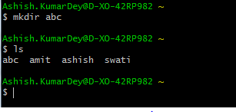

**>> mkdir file1 file2 file3:-** This command helps you to create multiple directories inside a directory.

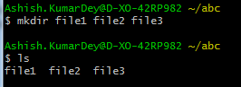

**>> mkdir -p file1/fill1 :-** This command helps you to create sub-directories of a directory. It will create parent directory first, if it is not exist. However, if it already exists, then it will not print any error message and will move further to create sub-directories.

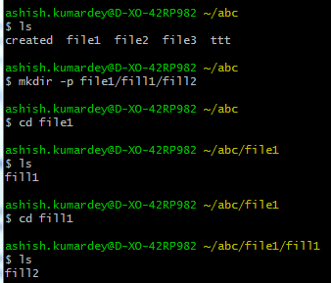

**>> mkdir -v aaa :-** This command helps you to print a message to every new directory / file created.

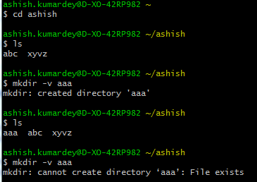

>> **mkdir -vp aaa/bbb/ccc/ddd :-** This command helps you to create a long list of files / directories together with a printed message.In addition to this , if the directory already exists , then it will not print any error message and will create further files/directories.

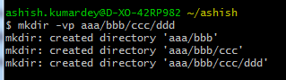

**>> mkdir -m = rwx(i.e.mode) hiendra :-** This command helps you to provide permission on the directory you are creating.

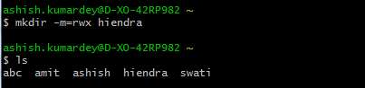

**Note :- rwx – Read , Write , Execute.**

**>> rmdir aaa:-** This command helps you to remove directory. But, in order to delete, the directory has to be empty. In addition to this , it will not delete a directory including a sub-directory.

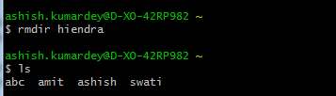

>> rmdir -p :- This command helps you to remove a directory including all its sub-directories all at a once.

Doubt

**Linux Files**

In Linux system, everything is a file and if it is not a file, it is a process. Files are always case sensitive.

For ex: - We have two files named Demo.txt and demo.txt.Although , they both share the same name but still they are two different files.

**>> file <filename>:-** This command helps us to determine the file type.It does not care about the extension used for the file.

i.e. file file2

file2: directory

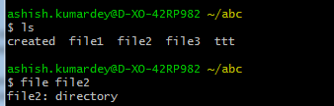

**>> file -s <filename>:-** This command is used for the special files.

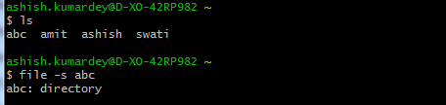

**>> file *: -** This command is used to obtain the type of all files of a current directory.

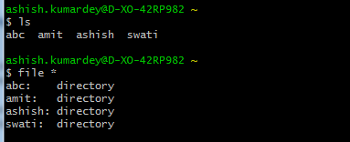

**>> file [range]*: -** This command helps you to track the range of the alphabets for the files you want. It will list out only those files which starts from the alphabets present in the range.

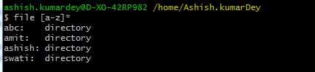

**Linux Touch commands**

**>> touch <filename> :-** This command helps you to create empty files.

**i.e. touch swati1 swati2**

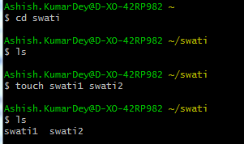

More commands on touch , need to cover up latter.

**Linux Delete File**

**>> rm:-** This command stands for remove which helps you to remove a file. Once you have deleted a file, it is removed permanently.

i.e. **rm<filename> = rm swati2**

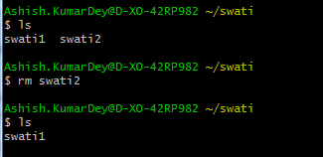

>> **rm *<extension> :-** This command helps you to remove all files ending with same extension like .txt , .pdf , .png etc.

For ex :- **rm *.txt**

**>> rm -r <dirname>:-** This command helps you delete a directory having sub-directories inside it.

i.e **rm -r abc**

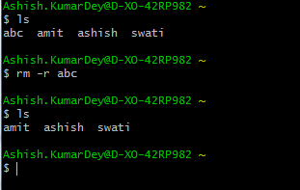

**>> rm -i <filename>: -** This command stands for interactivity which helps you to delete a file in a directory. But, it will ask whether you want to delete it or not .

**i.e. rm -i a.txt**

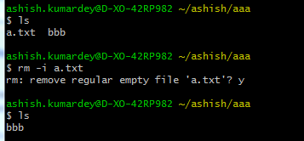

**>> rm -ri<dirname>: -** This command helps you to delete a directory .In addition to this , it will also delete sub-directories as well.But , before it deletes it will ask whether you want to delete it or not.

**i.e.rm -ri bbb**

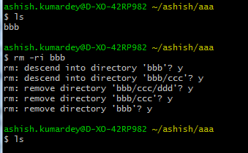

**>> rm -f<filename>: -** This command helps you to remove the file forcefully. It means the file will be deleted anyhow even it has a read only permission.

**>> rm -rf<dirname>:-** This command helps you to remove the directory forcefully.

**>> cp:-** This command stand for copy which helps you to copy a file or directory.

**>> cp <existing file name> <new file name>:- This command helps you to cope a file into a directory.**

**i.e.cp newFile xyvz**

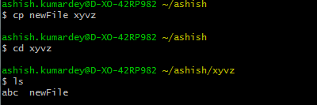

**Copy newFile to new**

**i.e.cp newFile new**

This command helps you to create a new directory new in the existing directory i.e.xyvz

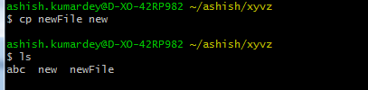

**>>** **cp test.txt /home/ashish.kumardey/ashish:-** This command helps you to copy test.txt file in ashish directory by specifying the full path.

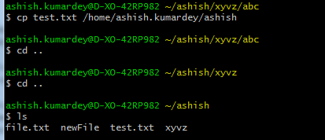

**>>cp -r source /home/ashish.kumardey/destination:-** This command helps you to copy one directory including its sub-directories to another directory by specifying the full path.

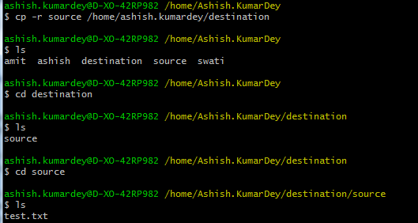

**>> cp *.txt destination: -**This command helps you to copy multiple files to a directory by specifying the full path.

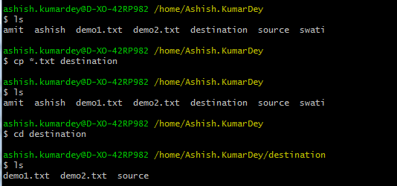

**>> cp - - backup demo1.txt /home/ashish.kumardey/destination/source:-** This command helps you to take back up of a file in same directory or different directory by specifying the full path.

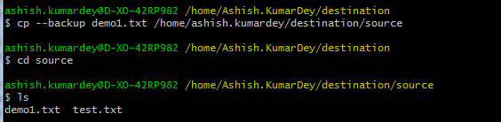

**>> cp -i demo1.txt /home/ashish.kumardey/destination:-** This command helps you to override file in same directory or different directory followed by asking the permission to override the file or not.

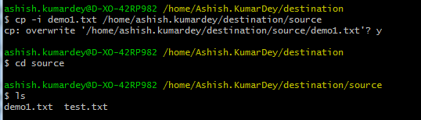

**>> cp -p demo1.txt /home/ashish.kumardey:-**This command helps you to preserve the properties and attributes of a file.

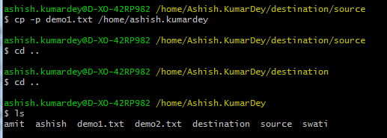

**>> cp -u -v demo1.txt /home/ashish.kumardey/destination/source:-** This command helps you copying big files.

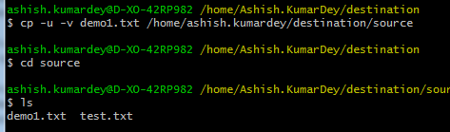

**Linux Rename File and Directory**

Rename of a file can be done by other command as well i.e. **mv**. But, **rename** command is slightly advanced. It is mainly used for renaming large group of files at once. In addition to this, it can convert upper case file to lower case file and vice versa and can override files using Perl script.This command is also a part of Perl script.

>> Need to check rename command.

# Linux Move File

# Linux mv command is used to move existing file or directory from one location to another. It is also used to rename a file or directory .

# >> mv test.txt /home/ashish.kumardey/destination: -This command helps you to move file i.e.test.txt from one directory i.e. source to another directory i.e. destination.

# 

# >> mv destination /home/ashish.kumardey/source: -This command helps you to move a directory i.e. destination to another empty directory i.e. source.

# 

# >> mv ashish /home/ashish.kumardey/ashish_kumar:-This command helps you to rename a directory name i.e.ashish to another name i.e.ashish_kumar.

# 

# >> mv -i test.txt /home/ashish.kumardey/ashish_kumar:- This command helps you to move a file i.e test.txt to a directory i.e.ashish_kumar followed by asking permission to over write it.

# 

# >> mv * /home/ashish.kumardey/source:-This command helps you to move all files and directories to any directory location.

# 

# Linux File Contents Commands

# There are many commands which help us to look at the contents of a file.

# >> head:-This command displays the starting content of a file. By default , it displays the starting 10 lines of a file.

# i.e.head test.txt

# 

# >> head <filename1><filename2>:-This command displays first 10 lines of each file separately by a heading.

# i.e. head set.txt test.txt

# 

# >> head -n <filename>:-This command displays specified number of lines.

# i.e. head -5 set.txt

# 

# >> head -c number <filename>:- This command counts the number of bytes of a file.

# i.e. head -c 90 set.txt

# 

# >> tail <filename>:- This command displays the last lines of a file. By default , it will displays the last 10 lines of a file.

# i.e. head set.txt

# 

# >> tail -n<number> <filename>:- This command displays the specified number of lines.

# i.e. tail -n2 set.txt

# 

# >> tail -c<number> <filename>:- This command displays the specified number of bytes from the last.

# i.e. tail -c2 set.txt

# 

# >> cat <filename>:- This command displays the content of a file.

# i.e. cat set.txt

# 

# >> cat <filename1> <filename2>:- This command displays the content of multiple files at once.

# i.e. cat set.txt test.txt

# 

# >> cat > <filename>:- This command greater then sign (>) is used to create new file.

# i.e. cat > javatpoint

# 

# Note :- Press 'enter' after every line and you will be directed to the next line. To save your file, go to the next line, press 'ctrl+d' and your file will be saved.

# >> cat >> <filename>:- This command with double greater then sign (>>) append something in your already existing contents in file.

# i.e. cat >> set.txt

# 

# Note :- To save the file press **'ctrl + d'**.

# >> cat <older_filename> > <newer_filename>:- This command used to copy contents from existing file to new file.

# i.e. cat javatpoint > javaTpoint

# Need to check this……

# >> cat <filename1> <filename2> <filename3> > <new filename>:- This command used to copy the contents from multiple files to a new file.

# i.e. cat set.txt test.txt > combo

# 

# >> cat - <filename1> <filename2> <filename3> > <new filename>:- This command using hipen (-) used to append a new line at the beginning of the new file only.

# i.e. cat - set.txt test.txt > combo

# 

# >> cat -n <filename>:- This command displays the line number for each line in a file.

# i.e. cat -n set.txt

# 

# >> cat -b <filename>:- This command -b removes the empty lines in a file.

# i.e. cat -b set.txt

# 

# >> tac <filename>:- This command is used to display file contents in reverse order. It is the reverse of the cat command.

# i.e. tac sat.txt

# 

# >> tac <filename> - -separator <string>:- This command is used to separate the content from the mentioned string or keyword from rest of the file content.

# i.e. tac sat.txt - -separator “aa”

# 

# >> more <filename>: - This command is used to displays contents of larger file. It is more or less same as cat command but cat command output will scroll off your screen while more command displays output one screenful at a time.

# Following keys are used in 'more' command to scroll the page:

# Enter key: To scroll down page line by line.

# Space bar: To go to next page.

# b key: To go to the backward page.

# / key: Lets you search the string.

# i.e. more set.txt

# 

# Note :- more command mainly used for larger files.

# >> less<filename>: - This command is same as more command but include some more features.

# It automatically adjust the width and height of the terminal window, while more command cuts the content as the width of the terminal window get shorter.

# i.e. less set.txt

# 

# Note :- In the left corner , name of the file is displayed.

# Linux Filters

# Linux Filter commands accept input data from stdin (standard input) and produce output on stdout (standard output). It transforms plain-text data into a meaningful way and can be used with pipes to perform higher operations.

# These filters are very small programs that are designed for a specific function which can be used as building blocks.

# >> cat <filename>  | cat or tac  |cat or tac  |… :- This command is used inside pipes , it does nothing except moving stdin to stdout.

# i.e. cat weeks.txt |tac|cat|tac|

# 

# Note:- Output of one cat or tac command is passing onto another as input.

# >> cut -d(delimiter) -f<columnNumber> <filename>:- This command is used to select the specific column of a file.

# Here, -d stands for delimiter from where you want to separate the column .In addition to this , delimiter can be space(‘ ‘) , a hyphen(-) , a slash (/) or anything else. After (-f), column number is mentioned.

# 

# >> grep:- This command stands for “global regular expression print”.grep command filters the content of a file which makes our search easy.

# i.e.cat marks.txt | grep 9

# 

# It can also be used without pipe too.

# >>grep Ashish marks.txt:- This command also be used without pipe too.

# 

# >>grep -v 9 marks.txt: - This command is used to displays lines that does not contain our search word 9.

# 

# >>grep -i 8 marks.txt: - This command displays lines containing 8 whether in upper case or lower case.

# 

# >>comm: - This command is used to compare two files. By default, comm will always display three columns. First column indicates non matching items of first file , second column indicates non matching items of second file and the third column indicates common items of both files.

# Note :- This command can only be used , if both the files are in sorted order.

# i.e. comm file1.txt file2.txt or comm file2.txt file1.txt

# 

# >> Comm -23/-13/-12 file1.txt file2.txt:- This command is used , if you want to display single column.

# Here , -23 will display the file1.txt non common items.

# -13 will display the file2.txt non common items.

# -12 will display the both files i.e.file1.txt and file2.txt common items.

# 

# >>sed: -This command stands for stream editor. You can use this command to edit streams of a file file3.txt>However , this editing is not permanent. It remains only in display , but in actual ,file contents remain same.

# i.e.sed command | sed ‘s/old_word/new_word/’

# 

# >>sed | sed ‘s/Status/Stature/g’: -This command using parameter ‘g’ is used to replace all Status in a file i.e.file3.txt to Stature.

# 

# >>cat | sed ‘/good/d’:-This command using parameter ‘d’ is used to remove the entire line of file i.e.file3.txt

# 

# Note :- Removed line ‘’This is good time to start”.

# >>tee: -This command is used to put contents to a new file. It is similar to cat command.

# i.e.cat weeks.txt | tee new.txt

# 

# >>tr:- This command stands for ‘translate’. It is used to translate from lowercase to uppercase and vice versa or new lines into spaces.

# i.e. cat exm.txt | tr ‘yellow’ ‘YELLOW’

# 

# >>tr -s:- This command squeezes the occurrence of multiple characters into one.

# i.e. cat exm.txt | tr -s ‘yellow’

# 

# >>tr -s ‘ ‘ :- This command squeezes the all the spaces into the single space.

# i.e.cat exm.txt | tr -s ‘ ‘

# 

# >>tr ‘a-z’ ‘123456789’:-This command encrypts the text. It is case sensitive.

# i.e.cat exm.txt | tr ‘a-z’ ‘123456789’

# 

# Note :- Uppercase are not encrypted as they are in upper case.

# >>tr -d ‘Apple’:- This command is used to delete characters.

# i.e.cat exm.txt | tr -d ‘Apple’

# 

# >> uniq: - This command is used to form a sorted list in which every word will occur only once.

# i.e. sort dupli.txt | uniq

# 

# >> uniq -c:- This command is used to count the number of occurrences of a word .

# i.e. sort dupli.txt | uniq -c

# 

# >>wc:- This command is used to help in counting the lines , words and characters in a file.

# i.e. wc exm.txt

# 

# >>wc -l: - This command helps in counting the lines.

# i.e. wc -l exm.txt

# 

# >>wc -w: - This command helps in counting the words.

# i.e. wc -w exm.txt

# 

# >>wc -c: - This command helps in counting the characters.

# i.e. wc -c exm.txt

# 

# >>od: -This command stands for octal dump. It displays content of a file in different human readable format like hexadecimal, octal, ASCII characters.

# >>od -b: -This command display file in octal format.

# i.e. od -b exm.txt

# 

# >>od -tx1: -This command display file in hexadecimal byte format.

# i.e. od -tx1 exm.txt

# 

# >>od -c: -This command display file in ASCII character format.

# i.e. od -c exm.txt

# 

# >>sort: -This command sorts the file content in an alphabetic order.

# i.e. sort weeks.txt

# 

# >>Gzip: -This command is used to truncate the file size. By default , original file size will be replaced by the compressed file ending with extension (.gz)

# i.e. gzip test.txt set.txt

# 

# >>gunzip: -This command is used to decompress a file and your original file will be back.

# i.e. gunzip test.txt set.txt

# 

# >>cat <file1> <file2> | gzip > newFile.gz: -This command is used to compress multiple files together.

# i.e. cat test.txt set.txt | gzip > final.gz

# 

# >>gzip -l <filename.gz>: -This command is used to give information regarding the compression ratio or how much the original file has compressed.

# i.e. gzip -l final.gz

# 

# >>tar : -This command is used to compress a directory.

# Need to discuss this.

# Linux Man Command

# The man command is a short term for manual page. In Unix , man is an interface to view the system’s reference manual.

# A user can request to display a man page by simply typing man followed by a space and then argument. Here , argument can be command , utility or function .A manual page associated with each of these arguments is displayed.

# >> man argument <i.e. command>

# i.e. man ls

# 

# This command will display all the information about ls.

# Note:- To go to the next page use f and use b go to the backward page. To exit from the screen use q and use h for help.

# Man page is divided into different sections. The man page have a number written in the parentheses after the command .The number represent the section number. In the above figure LS(1) at the top , which shows that it is from section number 1.

# >> man -aw command:- This command is used to view all the sections of a particular command /topic in a man page.

# i.e. man -aw chmod

# 

# Linux Tools :-

# Basic Unix tools are used to do basic work like find a file , locate a file , set date and time , display calendar etc.

# >>find:- This command helps us to find a particular file within a directory. It is also used to find a list of files having same pattern name.

# (.) :- For current directory name .

# (/) :- For root.

# i.e. find . -name “*.txt”

# 

# Note :- The above command search all the files ending with .txt extension.

# >> find . -newer weeks.txt :- This command is used in searching the files which are newer then the mentioned file.

# 

# Note:- In the above snapshot , all the files displayed are newer then the weeks.txt file.

# >>locate <FileName>:- This command is a background process and searches the file in the database.

# 

# Note :- Loacte command is much faster then the find command.

# >>date :- This command displays date, time , time zone etc.

# 

# >>cal :- This command displays calender i.e. current month and current day highlighetd.

# 

# >>cal <year> <month> :- This command displays past or future year month .

# 

# >>sleep :- This command let the terminal wait by specified amount of time.By default , it takes time in seconds.

# 

# >>time :- This command displays how long it takes to execute a command.

# 

# >>zcat :- Compreassed and zipped file contents can be viewed .

# 

# >>bzip2 and bunzip2 :- This command helps to compress file which takes little time but in a better way like gzip command.

# While bunzip2 command helps to decompress a file like gunzip command.

# 

# >>bzcat :- This command helps to display the files compressed particularly bz2 extension files.

# 

# >> df :- This command helps tells about the disk space used in the file system.It defines the number of blocks used , number of blocks available and the directory where the file system mounted.

# 

# 

# Linux Networking :-

# >> traceroute :- This command is a network troubleshooting utility which helps us to determine number of hops and packets travelling path required to reach the destination.

# 

# >> tracepath :- This command is similar to traceroute but it doesn’t require root privileges .By default , it is installed in Ubuntu but you may need to download and install traceroute on Ubuntu. It traces the network path of the specified destination and reports each hop along with the path. If your network is slow then it will show where your network is weak.

# 

# >> ping: - This command stands for “Packet Internet Groper”. It checks the connectivity between two nodes whether a server is reachable or not.

# Ping command keeps executing and sends packets until we interrupt.

# We can IP address with ping command.

# Note :- To stop executing ping command continuously use ctrl+c.

# 

# >>netstat: - This command stands for network statistics. It displays information about different interface statistics including open sockets, routing tables and connection information.

# 

# >> netstat -p:- This command is used to display programs associated with open socket.

# 

# >> netstat -s: - This command is used to display detailed statistics of all ports .

# 

# >> netstat -r: - This command is used to displays routing table information.

# 

# >> dig: - This command stands for Domain Information Groper. It mainly deals with troubleshoot DNS related problems. This command is used to query DNS name servers.

# i.e. dig javatpoint.com

# 

# >> nslookup:- This command is used to find the DNS related query.

# 

# It displays the record information of javatpoint.com

# >>ifplugstatus :- This command let us know whether a cable is plugged into our network or not .By default , it is not installed in Ubuntu and to install it use command sudo apt-get install ifplugd.

# 

# In the above snapshot, it shows the status of all interfaces. Here , link beat detected means it is plugged in.In our system , lo and wlan0 are plugged in while eth0 is unplugged.

# >> whois:- This command is used to display information about a website’s record. You may get all information about a website regarding its registration and owner’s information.

# i.e. whois javatpoint.com

# 

# In the above snapshot, you can see all types of website information.

# >>mtr :- This command is a combination of ping and traceroute command. It continuously sends packets showing ping time for each hop. It also shows network command.

# i.e.mtr javatpoint.com

# In the above snapshot, hop4 is loosing over 50 % of the packets. To exit press ctl+c.

# >> curl -O <fileLink> :- This command is used to download a file from internet using CLI.Moreover , the file will be saved in the current directory.

# i.e. curl -O https://www.google.com/doodles/about

# 

# In the above snapshot , we have downloaded one file with the help of curl -O command.

# >> wget <fileLink> :- This command is used to download a file without using any option.

# i.e. wget <https://www.google.com/doodles/clare-hollingworths-106th-birthday>

# 

# In the above snapshot , we have downloaded one file with the help of wget command.

# >>hostname :- This command is used to display the hostname of the system.

# 

# In the above snapshot , our hostname is RHPRE-BR-01.

# >>iwconfig:- This command configures a wireless network interface. Moreover, we can view and set basic wi-fi details like SSID and encryption.

# 

# >>arp:- This command stands for Address Resolution Protocol. It allows us to view or add content into kernel’s ARP table.

# 

# Linux System Admin Commands: -

# A system administrator manages configuration, upkeep and reliable operations of computer operations. A system administrator only deals with terminal interface.

# >> man:- This command is used to display information about all commands.

# i.e. man ls

# 

# >>uptime: - This command is used to show how long a system has been running .

# 

# In the above snapshot, the command uptime displays output in one line.

# From the left it shows,

# Current system time.

# Duration for which system has been running (system has been running since 506 days )

# Number of users logged in (1 user is logged in)

# System load average CPU load for past minutes.

# Here, system load averages are the processes which are either in runnable or in uninterruptable state.

# A runnable process may be either a running one using CPU or waiting to use CPU. An uninterruptable process is waiting for some I/O access.

# >> uptime -V: - This command is used to display version information.

# 

# >>service :- The service command starts , stop and restart a daemon or services by calling the script.Usually all scripts are stored in /etc/init.d directory.

# service script_name start(To start the service)

# i.e. service tomcat5 start

# service script_name stop(To stop current service)

# i.e. service tomcat5 stop

# service script_name restart(To restart the service)

# i.e. service tomcat5b restart

# service script_name status (To know the current status)

# i.e. service tomcat5 status

# >>Terminating: - There are four ways to kill or terminate a process. These commands allow you to run the system uninterruptedly after terminating a process without rebooting a system. These commands can be internal or external.

# >>kill:- The most common command to terminate a process is kill command. You need to know the PID of the process you want to terminate. Kill command sends signal to the specified process. For sending signal either signal name and signal number can be used.

# 